1. **Go to Login section – websitelink/en/user/login**

Admin username: meheadmin

Admin password: meheadmin

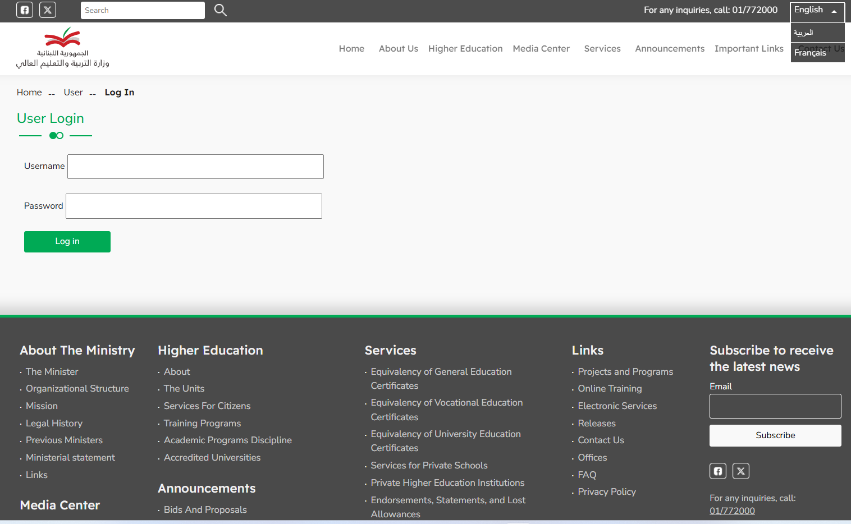

1. **After login the go to content section where all the content can be filtered by title / type / status / language**

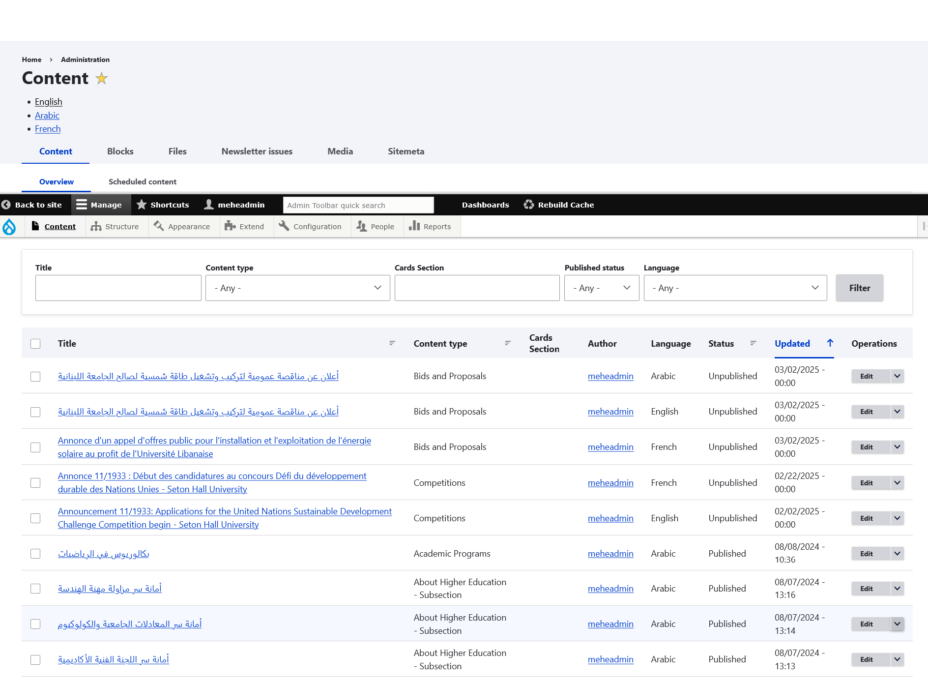

1. To create a new content go to shortcuts - > add content

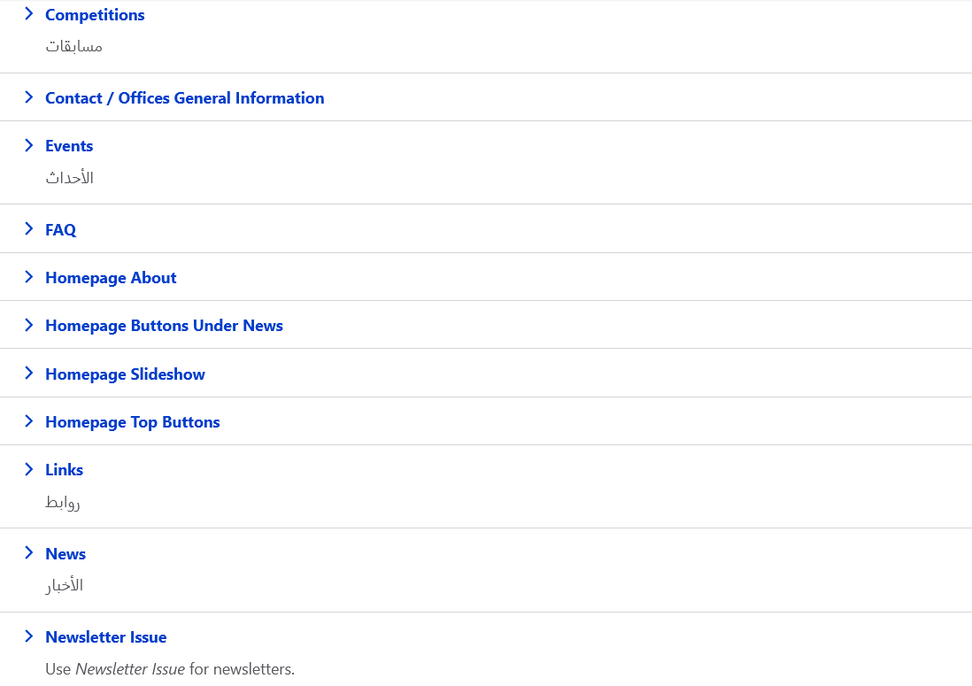

1. Choose for example news section to create a new News

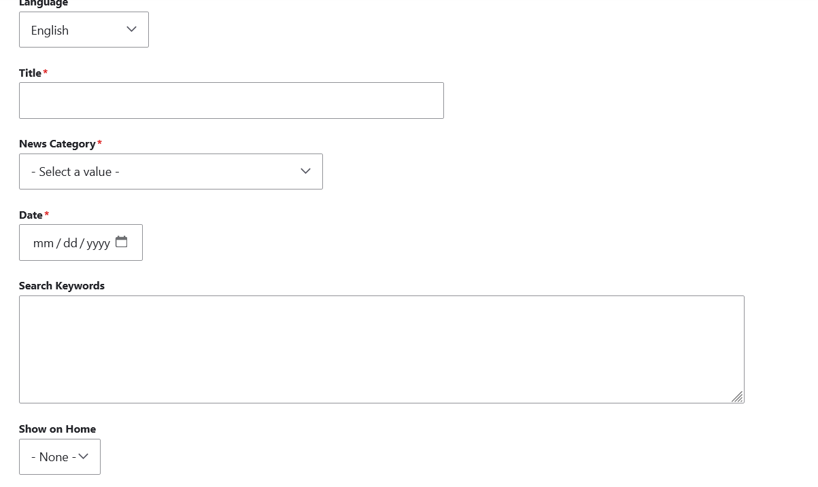

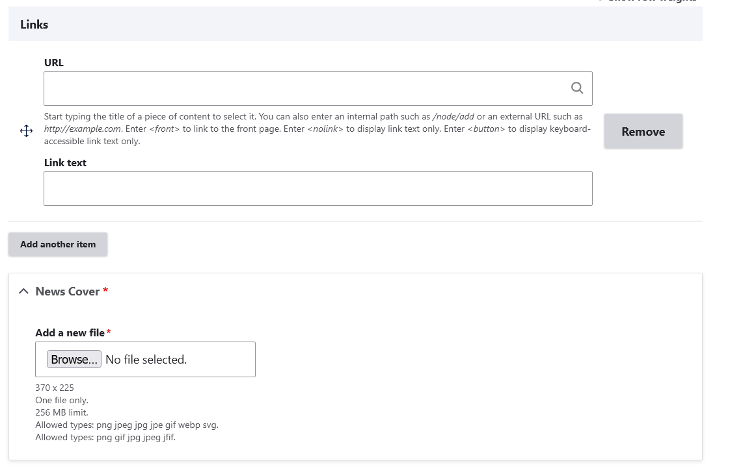

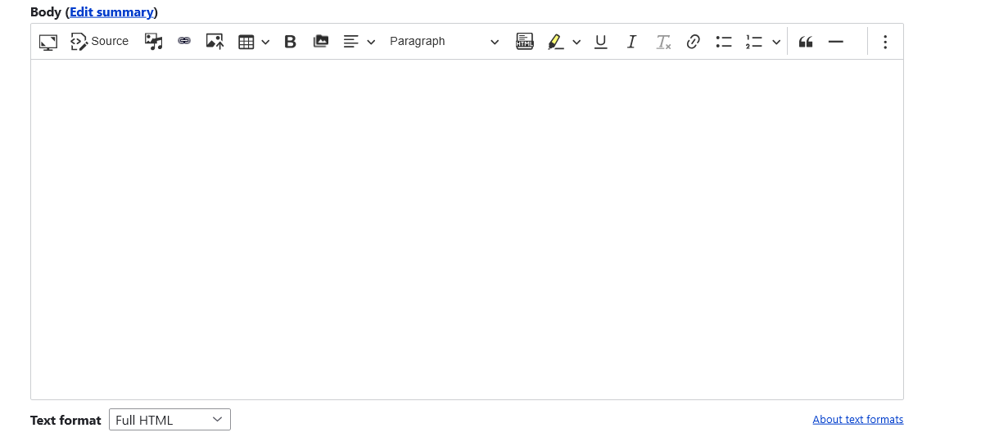

Change the body from Filtered HTML to Full HTML.

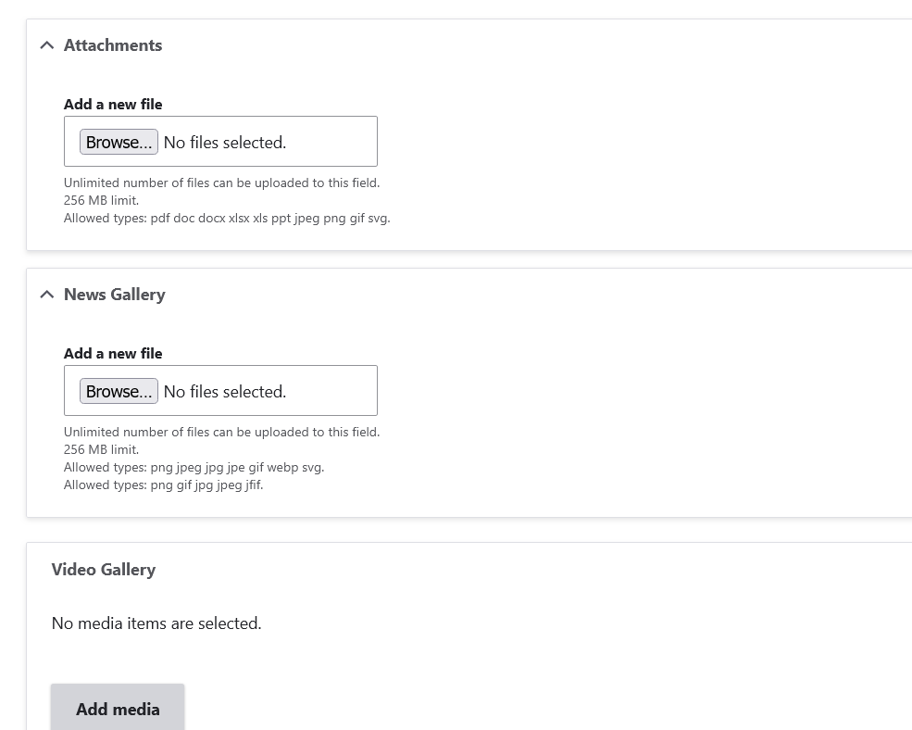

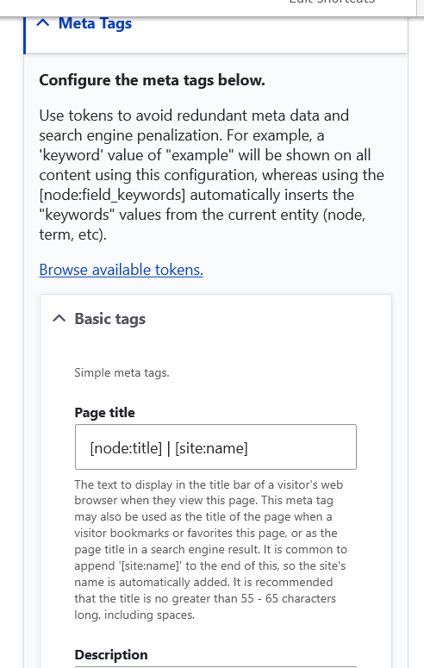

Fill Meta Page Title and Page Description.

1. To check the different webforms go to structure – webforms

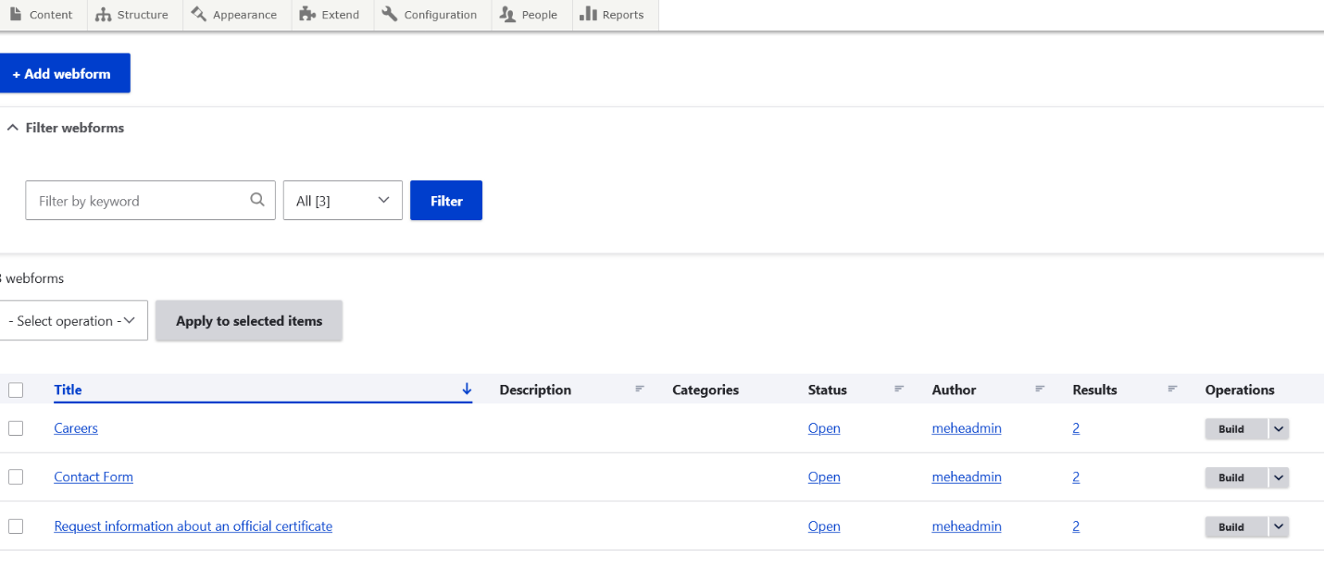

1. Go to Careers – Click the arrow near Build and click Results

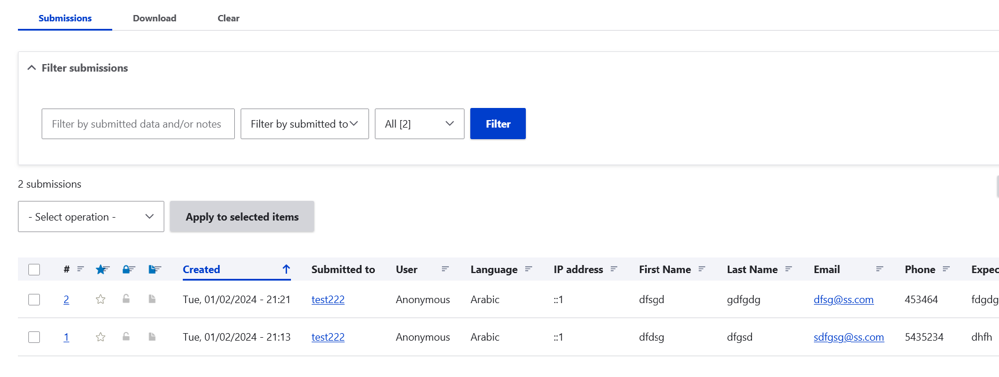

1. To add a category or tag go to Structure - > Taxonomy

